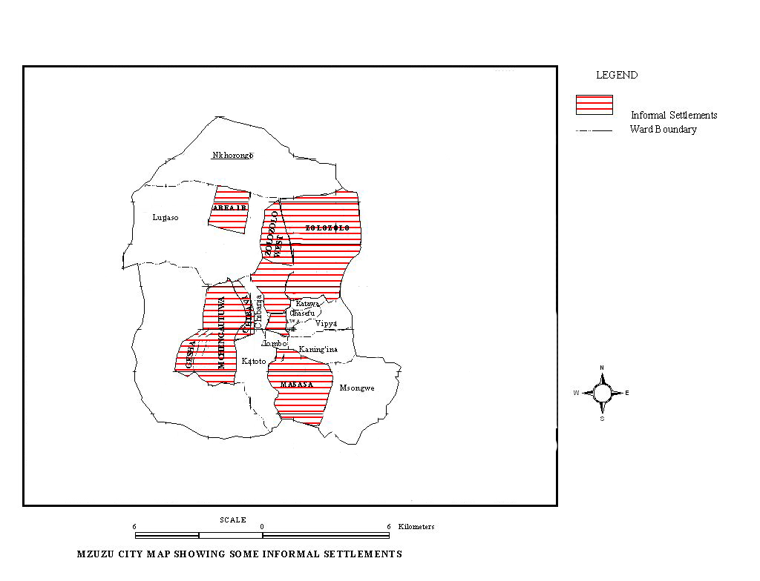
Figure 2 showing informal settlements in Mzuzu City

